Civics Syllabus
***Read and Sign: due August 22, 23 2019
***Materials: due August 26, 27 2019
Room #550 (Mr. Lawrence)
South Miami K-8 Center
email: nlawrence@dadeschools.net
Teacher Website: www.eduk8.org ------(Teacher Info., Homework, Projects, Additional Resources, etc.)

Welcome! I hope your summer was restful. This year we will have the opportunity to learn about Civics. We will learn about the origins and purposes of law and government, the organization and function of government, the roles, rights and responsibilities of citizens, and government policies and political processes.

Civics End-Of-Course (EOC) Exam:
***State Requirement: “Florida Senate Bill 1076 requires that students enrolled in specific courses take Florida’s End-Of-Course (EOC) assessment for the course; the results must constitute 30% of the student’s final grade.”*** -It is critical that you score a 3 or higher on the Civics EOC Exam to successfully pass this course.

7th Grade Civics Course Description:
The seventh grade social studies curriculum consists of the following content area strands: Civics, Geography, and Economics. The primary content for the course pertains to the principles, functions, and organization of government; the origins of the American political system; the roles, rights, responsibilities of United States citizens; and methods of active participation in our political system. The course is embedded with strong geographic and economic components to support civic education instruction.

Please have the following SUPPLIES each day for a resourceful year:
- One notebook (for this class only) | - One folder with pockets (for this class only)
- Lined loose leaf paper | - Pen and pencil
- Highlighter | - Eraser
- Earbud headphones | - Pencil sharpener
Not required, but will be very useful:
One box of colored pencils, ruler (for personal use)
(Classroom Donations) tissue paper, hand sanitizer
*Please put your name, date and period on your materials, so you receive credit.

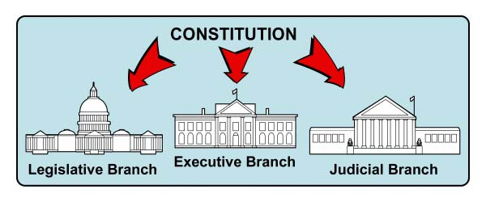
Grading Policy:
100-90% = A  (4 points - 3.5 points) | 89-80% = B (3)  (3.49 points – 2.5 points) | 79-70% = C (2)  (2.49 points – 1.5 points) | 69-60 = D  (1.49 points – 1.0 points) | 59-1% = F  (.99 points – .01points) | 0% = Z  (0.00 points)
In this class we will be using the standard 4 point grading scale. I try my best to ensure a fair grading policy for all students. Although not exact, I generally try to stick to the following formulation with my grading:

Classwork/Homework: 40% Quizzes/Tests: 40% Projects: 20% =100% (Overall Grade)

For each school day, these are my  Classroom Expectations:  - Be seated & on task when the bell rings  - Bring all materials to class when they are due  - Be respectful to yourself and to others  - No personal grooming or personal electronic devices during class.  - Follow directions and complete tasks on time | Penalties: Three strikes equals a referral.  Name recorded with warning (will not be erased until the end of the week)  X Name: Call home  XX Name: Call home/Detention  XXX Name: Referral
*Detentions are held on most Wednesdays from 2:10-3:10 p.m.
*For more serious infractions I reserve the right to immediately write a referral*
Return this page to Mr. Lawrence by August 22, 23, 2019

Rewards (Must not have a call home, detention, or referral during the quarter):
Rewards-- will be given at the end of each quarter

We have read and agree to Mr. Lawrence’s Civics syllabus

______________________________________ __________
(Student Signature) (Date)

______________________________________ __________
(Parent Signature) (Date)

Student Name:____________________________________________ Period #:______

Parent(s)- Please fill out the information below with the best phone number and
email to reach you below:

Parent Name:__________________________________________________________

Parent Phone #:________________________________________________________

Parent email:__________________________________________________________

Something I would like you to know about my child is…
__________________________________________________________________________________________________________________________________________________________________________________________________________________

