Notes 6.1- Parts of the Atom

How can the subatomic particles of an atom be used to identify it?
The number of protons in the nucleus of an atom identifies the element of that atom.
- Protons are found in the nuclei of atoms, are positively charged, and have a mass of 1 amu.
- Neutrons are found in the nuclei of atoms, have no charge, and have a mass of 1 amu.
- Electrons are found surrounding the atom’s nucleus. They have a negative charge and mass equal to 1/1836 of a proton.
- Most of the mass of an atom is accounted for by its nucleus.
- The charge on an atom depends on the number of protons and electrons the atom holds.

How can isotopes of a given element be identified?
The isotopes of a given element vary in the number of neutrons in their nuclei.
- The isotopes of an element are atoms that have the same number of protons but different numbers of neutrons.

How can the quantity of protons, neutrons, and electrons in an atom be determined?
The atomic number and mass number of an atom can be used to determine the quantity of protons, neutrons, and electrons in the atom.
- The number of protons in an atom equals its atomic number.
- To find the number of neutrons in an atom, you subtract the atomic number from the mass number.
- A neutral atom contains the same number of electrons as protons.

What is the difference between atomic mass and atomic number?
The atomic number of an element can be determined by considering the number of protons in its atoms. The atomic mass of an element is determined by considering the masses of its natural isotopes.
- The atomic number of an element equals the number of protons in its atoms.
- The average of all the masses of an element’s natural isotopes equals its atomic mass .

How can the average atomic mass for an element be determined given the masses of its isotopes and their relative abundance?
The average atomic mass of an element can be determined by considering the masses of its natural isotopes and their abundance.
- To find the average atomic mass of an element, multiply the mass of each naturally occurring isotope of the element by its percent abundance, find the sum of these products, and divide by 100.

6.2- Development of the Atomic Theory

How did the atomic theory evolve from ancient Greece to modern day, and which key scientists made which contributions?
The atomic theory evolved over hundreds of years. Original development of the theory dates back to the time of the ancient Greeks.
- The first person to use the term "atom" was Democritus, a Greek philosopher.
- Aristotle believed there were four main elements – earth, wind, fire and water. He believed all other matter was made of these elements.

Many scientists made contributions to the development of the atomic theory:
- John Dalton first theorized that elements contained atoms of a single type. He believed that these atoms combined to form more complex structures.
- John Dalton's atomic theory had five parts:
  - All matter is composed of particles called atoms.
  - Atoms of a given element have unique properties. While atoms of a given element are identical, atoms of different elements differ in size, mass and properties.
  - Atoms cannot be subdivided, created, or destroyed.
  - Atoms of different elements combine in simple, whole-number ratios to form chemical compounds.
  - During chemical reactions, atoms are combined, separated or rearranged.
- Dalton’s theory supported other important physical laws, such as the law of conservation of mass, the law of definite composition, and the law of multiple proportions.
- J.J. Thomson used a cathode ray tube to determine that atoms contain negatively charged particles. He also developed the plum pudding model of the atom, which showed negatively charged electrons embedded in positively charged matter.
- Ernest Rutherford and his colleagues used the gold foil experiment to show that atoms contain a positively charged central region that contained most of an atom's mass. This nucleus was later found to contain protons and neutrons.
- Niels Bohr showed that electrons move around the nucleus in paths at distances related to energy levels.
- Modern quantum theory includes ideas about the probable locations of electrons in the electron cloud.
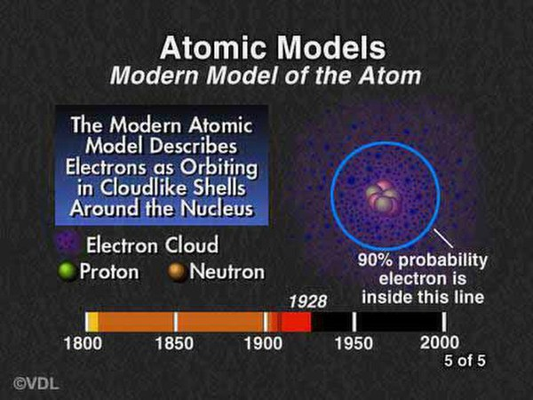
Modern Model of the Atom. The modern model of the atom describes negatively charged electrons orbiting around a positively charged nucleus.

6.3- Nuclear Chemistry

How do alpha, beta, and gamma radiation compare?
Three types of radiation that are released from unstable nuclides are alpha, beta, and gamma radiation:
- Alpha particles are composed of two protons and two neutrons. Alpha particles have fairly low energy and low penetrating ability.
- Beta particles are high-energy, high-speed electrons. They have about 100 times the penetrating power of alpha particles.
- Gamma rays are a type of light wave. They have short wavelengths and high frequencies. They have a large amount of energy and have a much greater penetrating power than beta particles have.

What conditions support the stability of a nucleus?
The stability of a nucleus depends on the ratio of neutrons to protons:
- A neutron/proton ratio of 1 to 1.51 is generally stable.

How do transmutation and chemical change compare?
Transmutation and chemical changes differ in several key ways:
- Although atoms do not change identity during chemical changes, atoms of one isotope often change into atoms of a different element during transmutation.
- Chemical changes involve changes to electrons, but transmutation involves changes to the nucleus.
- Nuclear equations are balanced so that the sum of the atomic numbers on each side is the same and the sum of mass numbers on each side is the same.

How do fission and fusion compare?
Two types of nuclear reaction are nuclear fission and nuclear fusion:
- In nuclear fission, a massive nucleus splits into smaller nuclei with the release of a large amount of energy.
- In nuclear fusion, two or more atomic nuclei join together to form a single heavier nucleus.
- During a nuclear reaction, a small amount of matter is converted into energy according to Einstein’s equation, E = mc².

How are chain reactions controlled in nuclear reactors?
A sequence of reactions is a chain reaction when something produced causes additional reactions to occur. Chain reactions are used in nuclear reactors:
- In a nuclear reactor, a chain reaction is started and controlled.
- The energy released during a controlled chain reaction in a nuclear reactor is used to form steam to drive a turbine to generate electricity.
- Challenges associated with the use of radioactivity to generate electricity includes the production of radioactive waste that must be stored for long periods of time and the potential for the accidental release of radioactive materials into the environment.

How is the half-life of radioactive materials used?
Half-life is a measure of how stable a radioactive nuclide is:
- Half-life is the time needed for one-half of a sample of radioactive material to decay.
- Half-life can be used to determine the length of time that has passed if the starting and ending amounts of nuclide are known.

