***Read and Sign: due August 22, 23 2019
***Materials: due August 26, 27 2019
World History Syllabus
Room #550 (Mr. Lawrence)
South Miami K-8 Center
email: nlawrence@dadeschools.net
Teacher Website: www.eduk8.org ------(Teacher Info., Homework, Projects, Additional Resources, etc.)

Dear Student and Parents/Guardians: I hope your summer was restful. I am looking forward to another wonderful school year!

COURSE DESCRIPTION:
The 8th grade World History social studies curriculum consists of the following content area strands: World History, Geography, Civics, and Economics. The primary content for this course pertains to the world’s earliest civilizations to the ancient and classical civilizations of Africa, Asia, and Europe. Students will be exposed to the multiple dynamics of world history including economics, geography, politics, and religion/philosophy. Students will study methods of historical inquiry and primary and secondary historical documents.

Please have the following SUPPLIES each day for a resourceful year:
- One notebook (for this class only) | - One folder with pockets (for this class only)
- Lined loose leaf paper | - Pen and pencil
- Highlighter | - Eraser
- Earbud headphones | - Pencil sharpener
Not required, but will be very useful:
(for personal use) One box of colored pencils, ruler
(Classroom Donations) tissue paper, hand sanitizer
*Please put your name, date and period on your materials, so you receive credit.

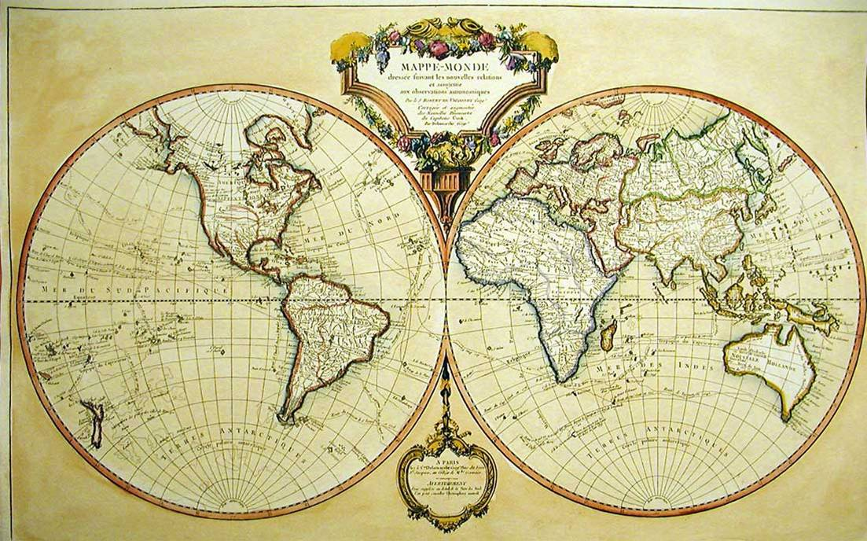
Grading Policy:
100-90% = A  (4 points - 3.5 points) | 89-80% = B (3)  (3.49 points – 2.5 points) | 79-70% = C (2)  (2.49 points – 1.5 points) | 69-60 = D  (1.49 points – 1.0 points) | 59-1% = F  (.99 points – .01points) | 0% = Z  (0.00 points)
In this class we will be using the standard 4 point grading scale. I try my best to ensure a fair grading policy for all students. Although not exact, I generally try to stick to the following formulation with my grading:

Classwork/Homework: 40% Quizzes/Tests: 40% Projects: 20% =100% (Overall Grade)

For each school day, these are my  Classroom Expectations:  - Be seated & on task when the bell rings  - Bring all materials to class when they are due  - Be respectful to yourself and to others  - No personal grooming or personal electronic devices during class.  - Follow directions and complete tasks on time | Penalties: Three strikes equals a referral.  Name recorded with warning (will not be erased until the end of the week)  X Name: Call home  XX Name: Call home/Detention  XXX Name: Referral
*Detentions are held on most Wednesdays from 2:10-3:10 p.m.
*For more serious infractions I reserve the right to immediately write a referral*
Return this page to Mr. Lawrence by August 22, 23, 2019

Rewards (Must not have a call home, detention, or referral during the quarter):
Rewards-- will be given at the end of each quarter

We have read and agree to Mr. Lawrence’s World History syllabus

______________________________________ __________
(Student Signature) (Date)

______________________________________ __________
(Parent Signature) (Date)

Student Name:____________________________________________ Period #:______

Parent(s)- Please fill out the information below with the best phone number and
email to reach you below:

Parent Name:__________________________________________________________

Parent Phone #:________________________________________________________

Parent email:__________________________________________________________

Something I would like you to know about my child is…
__________________________________________________________________________________________________________________________________________________________________________________________________________________

